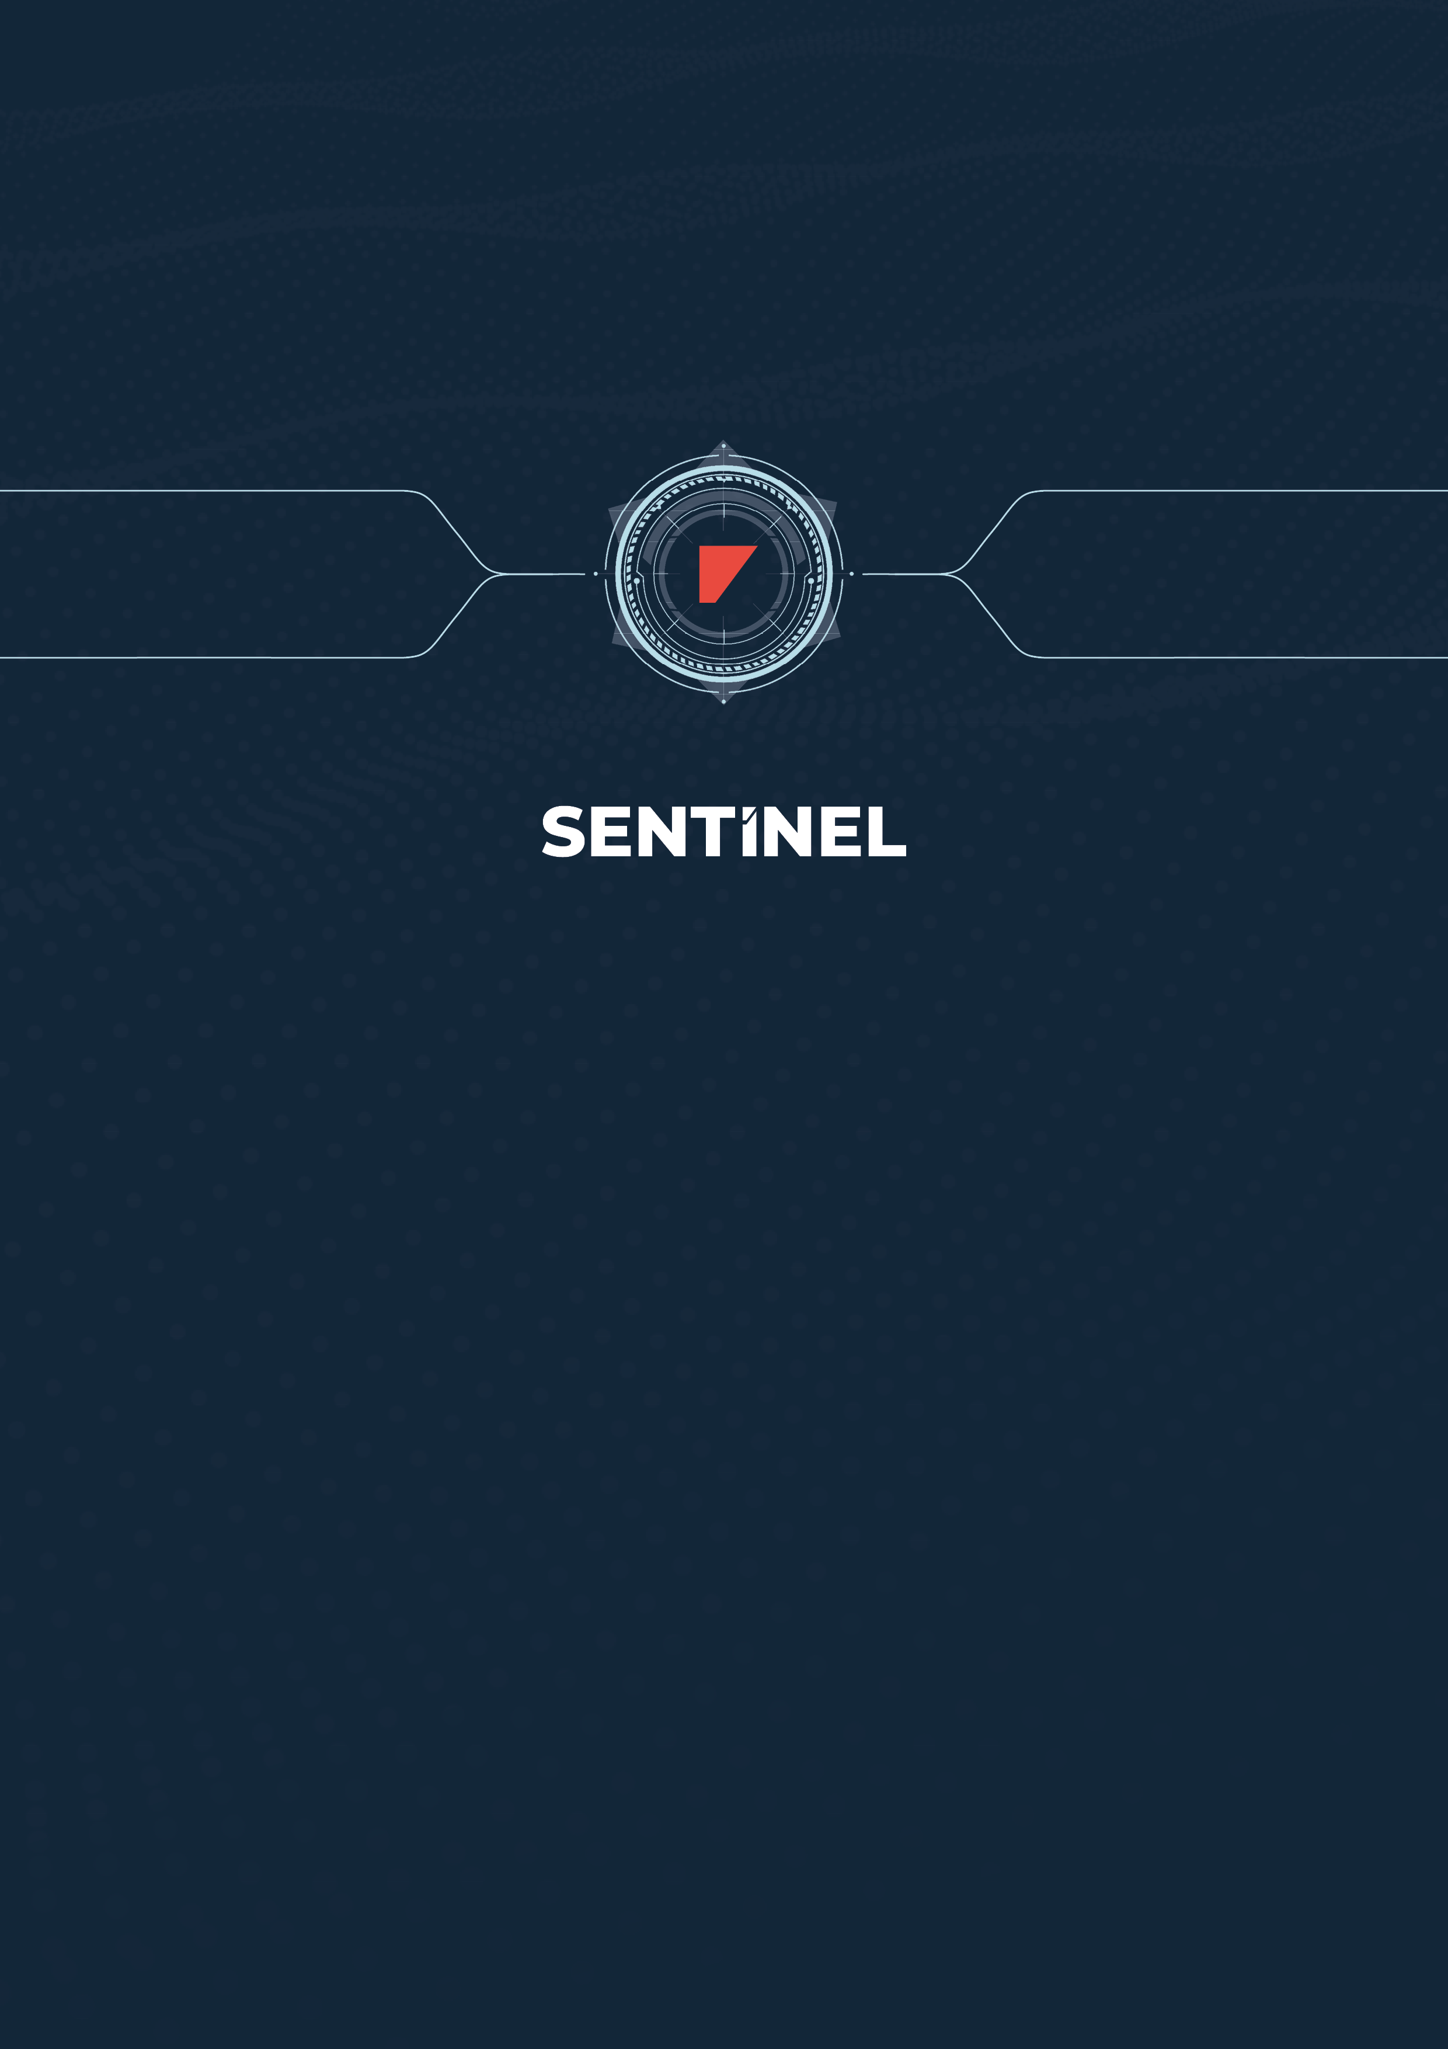

TERMS & CONDITIONS

Sentinel Service – FREE TRIAL Terms and Conditions

Please read these Terms and Conditions carefully.

These Terms and Conditions (Terms) provide important information. They, along with additional documentation available at [ambrey.com/intelligence] (Documentation) describe how Ambrey makes its Sentinel Service (Sentinel) and its associated services available to its clients, they set out each client’s rights and responsibilities and they tell clients what to do if there is a problem. These terms also limit Ambrey’s liability.

By submitting the Sentinel Onboarding Form to [INSERT THE EMAIL ADDRESS THESE ARE SENT TO] you are accepting these Terms, together with the provisions set out in the Sentinel Onboarding Form, on behalf of the organisation that you are employed or engaged by and whose details are provided in the Sentinel Onboarding Form (Client). If you do not agree to these Terms, or are not authorised to accept these Terms on behalf of the Client, you must not submit the Sentinel Onboarding Form.
- Order process
  - The Client may place an order (Order) by submitting a completed Sentinel Onboarding Form, which must include the following information:
    - the solutions required by the Client that are available via the Sentinel Service (each a Subscription Service)
    - the Commencement Date of the Trial
    - the Trial Period (which will be a period of 1 [INSERT THE MINIMUM TRIAL PERIOD] unless otherwise set out in the Order)
    - the vessels in respect of which the Client may use the Sentinel Service (each a Subscribed Vessel);
    - whether Ambrey will process any personal data on behalf of the Client. Where an Order does not specify this, Ambrey will not process personal data on behalf of the Client, the Client agrees not to provide any personal data to Ambrey and clause 3.5 will not apply.
  - An Order will only be accepted when Ambrey provides written acceptance of the Order by email, at which point a contract (Contract) will be created between Ambrey and the Client that is subject to the applicable accepted Order and these Terms. Ambrey reserves the right to accept or reject any Order. If Ambrey is unable to accept an Order, Ambrey will notify the Client as soon as possible.
- Sentinel and the Subscription Services
  - Ambrey hereby grants to the Client a non-exclusive, non-transferable right, without the right to grant sublicences, to access and use Sentinel, the Subscription Service(s) and the Documentation, during the Trial Period solely to evaluate the suitability of the Subscription Services for use in the Client's business operations.
  - The Client may authorise one user (each an Authorised User) to access and use Sentinel on its behalf. Authorised Users may use Sentinel to place additional Orders, configure the Subscription Service(s) and ascribe permissions to other Authorised Users.
  - In relation to the Authorised Users, the Client undertakes that:
    - it will not, and will ensure that no Authorised User will, use the Subscription Service(s) in respect of any vessel that is not a Subscribed Vessel;
    - the Authorised User shall keep a secure password for their use of the Subscription Service(s) and Documentation and shall keep such password confidential.
  - The Client shall not use Sentinel or the Subscription Service(s) in any manner that:
    - is, or may be, unlawful, harmful, threatening, defamatory, obscene, infringing, harassing or racially or ethnically offensive;
    - facilitates illegal activity;
    - depicts sexually explicit images;
    - promotes unlawful violence;
    - is discriminatory based on race, gender, colour, religious belief, sexual orientation, disability; or
    - is otherwise illegal or causes damage or injury to any person or property;
and Ambrey reserves the right, without liability or prejudice to its other rights to the Client, to disable the Client's or one or more Authorised User’s access to any material that breaches the provisions of this clause.
  - The Client must not:
    - except as may be allowed by any applicable law which is incapable of exclusion by agreement between the parties and except to the extent expressly permitted under the Contract:
      - attempt to copy, modify, duplicate, create derivative works from, frame, mirror, republish, download, display, transmit, or distribute all or any portion of Sentinel or the Subscription Service(s) and/or Documentation (as applicable) in any form or media or by any means; or
      - attempt to de-compile, reverse compile, disassemble, reverse engineer or otherwise reduce to human-perceivable form all or any part of Sentinel or the Subscription Service(s); or
    - access all or any part of the Subscription Service(s) and Documentation to build a product or service which competes with the Subscription Services and/or the Documentation; or
    - use the Subscription Service(s) and/or Documentation to provide services to third parties; or
    - subject to clause 1.1, license, sell, rent, lease, transfer, assign, distribute, display, disclose, or otherwise commercially exploit, or otherwise make the Subscription Services and/or Documentation available to any third party except the Authorised Users, or
    - attempt to obtain, or assist third parties in obtaining, access to the Subscription Services and/or Documentation, other than as provided under this clause 2; or
    - introduce or permit the introduction of, any thing or device (including any software, code, file or programme) which may: prevent, impair or otherwise adversely affect the operation of any computer software, hardware or network, any telecommunications service, equipment or network or any other service or device; prevent, impair or otherwise adversely affect access to or the operation of any programme or data, including the reliability of any programme or data (whether by re-arranging, altering or erasing the programme or data in whole or part or otherwise); or adversely affect the user experience, including worms, trojan horses, viruses and other similar things or devices (collectively referred to as Malware) into Ambrey's network and information systems or distribute or transmit any Malware.
  - The Client shall use all reasonable endeavours to prevent any unauthorised access to, or use of, the Subscription Services and/or the Documentation and, in the event of any such unauthorised access or use, promptly notify Ambrey.
  - The rights provided under this clause 2 are granted to the Client only, and shall not be considered granted to any subsidiary or holding company of the Client.
- Data protection
  - For the purposes of this clause the Data Protection Laws shall mean:
    - the EU Regulation 2016/679 (GDPR) as amended by Schedule 1 of The Data Protection, Privacy and Electronic Communications (Amendments etc) (EU Exit) Regulations 2019 (UK GDPR);
    - Data Protection Act 2018 (DPA); and
    - and all laws and regulations supplementing or replacing the UK GDPR and the DPA.
  - The terms personal data, controller and processor shall be as defined in the UK GDPR.
  - Where Ambrey receives personal data from the Client and is required to process such personal data on behalf of the Client to deliver the Subscription Service(s) or provide the Support, the Client is the controller of that personal data and Ambrey is the processor.
  - As the controller, it is the responsibility of the Client to inform individuals how their personal data is used and maintain the mandatory records required under Data Protection Laws.
  - Where Ambrey processes personal data for which the Client is the controller (as set out in the Contract) (Protected Data), it shall:
    - process Protected Data in line with the Client’s documented instructions (either as set out in the Contract, or as provided through the Client’s use of the Subscription Service(s) or Support);
    - ensure that its staff who have access to Protected Data are bound by obligations of confidentiality (which are included in its employment contract or equivalent contract with them)
    - have technical and organisational measures and procedures which ensure an appropriate level of security for Protected Data and reduce the risk of a security incident in which Protected Data has been accidentally or illegally destroyed, lost, changed or shared with, accessed or used by someone who did not have permission (Personal Data Breach);
    - only appoint third party data processors (who Ambrey instructs to help it deliver its Subscription Service(s) or Support) after it has notified the Client in writing and the Client has not objected within fourteen (14) days, and where Ambrey has an agreement with such data processors that includes provisions substantially similar to this clause 3.5. The Client hereby provides general consent to the appointment of such data processors;
    - not transfer Protected Data outside the UK or European Economic Area (other than where the Protected Data is stored on a Subscribed Vessel, which is itself outside the UK or European Economic Area) until after it has notified the Client in writing and the Client has not objected within fourteen (14) days;
    - promptly inform the Client if there has been a Personal Data Breach which impacts the Protected Data;
    - at the end of the contractual relationship, or any earlier written request from the Client, delete or return the Protected Data;
    - assist the Client and provide the information required to ensure the Client can comply with their obligations under the Data Protection Laws;
    - promptly inform the Client if it receives a request from or on behalf of an individual who wishes to exercise their rights under the Data Protection Laws, and provide assistance so the Client can respond to the request;
    - not disclose Protected Data without the Client’s written permission unless it is legally required to make the disclosure (in which case, Ambrey will promptly notify the Client unless it is prohibited from doing so); and
    - allow the Client to access its premises or records to audit its compliance with the Data Protection Laws, provided the Client gives seven (7) days’ notice.
- Third party providers
  - The Client acknowledges that the Subscription Service(s) may enable or assist the Client to access the data of third parties and that it does so solely at its own risk. Ambrey makes no representation, warranty or commitment and shall have no liability or obligation whatsoever in relation to the content or use of, or correspondence with, any such third-party.
- Ambrey's obligations
  - Ambrey undertakes that Sentinel will be provided, and the Subscription Service(s) and Support will be performed, substantially in accordance with the Documentation and with reasonable skill and care.
  - Ambrey:
    - does not warrant that:
      - the Client's use of Sentinel or the Subscription Services will be uninterrupted or error-free; or
      - that Sentinel, the Subscription Services, Documentation and/or the information obtained by the Client through the Subscription Services or Support will meet the Client's requirements; or
      - Sentinel or the Subscription Services will be free from Malware.
    - is not responsible for any failure of Sentinel or the Subscription Service(s) that is due to any fault, failure or error in any information, data or materials provided, or made available, to Ambrey by the Client; and
    - is not responsible for any delays, delivery failures, or any other loss or damage resulting from the transfer of data over communications networks and facilities, including the internet, and the Client acknowledges that Sentinel, the Subscription Services and Documentation may be subject to limitations, delays and other problems inherent in the use of such communications facilities.
- Client's obligations
  - The Client shall:
    - provide Ambrey with:
      - co-operation and access to staff and timely decision making in relation to the Contract; and
      - access to all required information, including but not limited to information relating to the Subscribed Vessels and their routes, security access information, configuration information, profile information for the Authorised Users who will receive alerts from Sentinel; and
      - access to the Subscribed Vessel, equipment, system and facilities;
as may reasonably be required by Ambrey to provide Sentinel and the Subscription Service(s);
    - without affecting its other obligations under the Contract, comply with all applicable laws and regulations with respect to its activities under the Contract;
    - carry out all other Client obligations set out in the Contract in a timely and efficient manner. In the event of any delays in the Client's performance of its obligations, Ambrey may adjust any agreed timetable or delivery schedule as reasonably necessary;
    - ensure that the Authorised Users use Sentinel, the Subscription Service(s) and the Documentation in accordance with the Contract, and shall be responsible for any Authorised User's breach of the Contract;
    - obtain and shall maintain all necessary licences, consents, and permissions necessary for Ambrey and its contractors and agents (including the Ambrey Personnel, if applicable) to perform their obligations under the Contract;
    - ensure that its network and systems required for use of Sentinel and the Subscription Service(s) comply with the relevant specifications provided by Ambrey from time to time; and
    - be, to the extent permitted by law and except as otherwise expressly provided in a Contract, solely responsible for procuring, maintaining and securing its network connections and telecommunications links from its systems to Ambrey's data centres, and all problems, conditions, delays, delivery failures and all other loss or damage arising from or relating to the Client's network connections or telecommunications links or caused by the internet.
  - The Client shall have sole responsibility for the legality, reliability, integrity, accuracy and quality of all data:
    - input onto Sentinel by the Client, any Authorised Users, or by Ambrey on the Client's behalf for the purpose of using the Services or facilitating the Client's use of the Services; or
    - to which access is provided by the Client to Ambrey. Collectively Client Data).
- Proprietary rights
  - The Client acknowledges and agrees that Ambrey and/or its licensors own all intellectual property rights in Sentinel, the Subscription Services and the Documentation. Except as expressly stated in these Terms, the Client is not granted any rights to, under or in, any patents, copyright, database right, trade secrets, trade names, trade marks (whether registered or unregistered), or any other rights or licences in respect of the Subscription Services or the Documentation.
  - To the extent that any intellectual property or other rights subsist in the Client Data, the Client warrants that it has the right to permit the use of such Client Data by Ambrey, as anticipated by the Contract. The Client hereby grants to Ambrey the non-exclusive right to copy, store and use such Client Data for the Trial Period to the extent necessary to provide Sentinel and the Subscription Service(s) to the Client.
  - Ambrey may use information and data that relates to the Subscribed Vessels, and that has been provided to or obtained by Ambrey in connection with the performance of the Subscription Services or Support (Vessel Data), in anonymised or aggregated form (without disclosure of personal information or information relating to one or more Subscribed Vessels to any third party), in perpetuity, to provide, improve and develop Ambrey’s products and services. To the extent that the Client owns any intellectual property or other rights in such Vessel Data, the Client hereby grants Ambrey an exclusive licence to use such Vessel Data for such purposes.
- Confidentiality
  - Each party undertakes that it will not at any time during this Agreement, and for a period of three (3) years after termination of this Agreement, disclose to any person any Confidential Information belonging to the other party except as permitted by clause 8.2.
  - Each party may disclose the other party's Confidential Information:
    - to those of its employees, officers, representatives or advisers who need to know such information for the purposes of exercising the party's rights or carrying out its obligations under or in connection with this Agreement. Each party will ensure that its employees, officers, representatives or advisers to whom it discloses the other party's Confidential Information are aware of that party’s obligations under this clause 14; and
    - as may be required by law, a court of competent jurisdiction or any governmental or regulatory authority.
  - The restrictions in clause 8.1 will not apply to such information that:
    - is public knowledge or already known to such party at the time of disclosure, or subsequently becomes public knowledge, in each case other than by breach of this Agreement; or
    - subsequently comes lawfully into the possession of such party from a third party.
  - No party will use any other party's Confidential Information for any purpose other than to exercise its rights and perform its obligations under or in connection with this Agreement.
- Limitation of liability
  - Except as expressly and specifically provided in a Contract:
    - the Client assumes sole responsibility for results obtained from the use of Sentinel, the Subscription Service(s) and the Documentation by the Client, and for conclusions drawn from such use. Ambrey shall have no liability for any damage caused by errors or omissions in any information, instructions or scripts provided to Ambrey by the Client in connection with Sentinel or the Subscription Service(s), or any actions taken by Ambrey at the Client's direction;
    - all warranties, representations, conditions and all other terms of any kind whatsoever implied by statute or common law are, to the fullest extent permitted by applicable law, excluded from the Contract; and
    - Sentinel, the Subscription Service(s) and the Documentation are provided to the Client on an "as is" basis.
  - Nothing in these Terms or the Contract excludes the liability of Ambrey:
    - for death or personal injury caused by Ambrey's negligence; or
    - for fraud or fraudulent misrepresentation.
  - Subject to clause 9.1 and clause 9.2:
    - Ambrey shall not be liable whether in tort (including for negligence or breach of statutory duty), contract, misrepresentation, restitution or otherwise for any loss of profits, loss of business, depletion of goodwill and/or similar losses or loss or corruption of data or information, or pure economic loss, or for any special, indirect or consequential loss, costs, damages, charges or expenses however arising under the Contract;
    - Ambrey's total aggregate liability in contract (other than in respect of the indemnity at clause 1.1), tort (including negligence or breach of statutory duty), misrepresentation, restitution or otherwise, arising in connection with the performance or contemplated performance of the Contract shall be limited to [£1,000].
- Term and termination
  - The Contract will expire at the end of the Trial Period, unless terminated earlier by either party on the provision of written notice to the other.
  - On expiry or termination of the Contract:
    - all licences granted under the Contract shall immediately terminate and the Client shall immediately cease all use of Sentinel and the Subscription Service(s) provided under the Contract;
    - subject to clause 7.3, Ambrey may destroy or otherwise dispose of any of the Client Data relating to the Contract; and
    - the rights, remedies, obligations or liabilities of the parties that have accrued up to the date of termination, including the right to claim damages in respect of any breach of the agreement which existed at or before the date of termination shall not be affected or prejudiced.
- General Terms
  - Relationship of the parties: The parties are independent businesses and not partners, principal and agent, or employer and employee, or in any other relationship of trust to each other.
  - Third party rights: These Terms do not confer any rights on any person or party (other than the parties to the Contract and, where applicable, their successors and permitted assigns) pursuant to the Contracts (Rights of Third Parties) Act 1999.
  - Assignment and other dealings: The Client shall not, without the prior written consent of Ambrey, assign, transfer, charge, sub-contract or deal in any other manner with all or any of its rights or obligations under the Contract. Ambrey may at any time assign, transfer, charge, sub-contract or deal in any other manner with all or any of its rights or obligations under a Contract.
  - Entire Agreement: The Contract contains the whole agreement between the parties relating to its subject matter and supersedes any prior agreements, representations or understandings between them unless expressly incorporated by reference in the Contract. Each party acknowledges that it has not relied on, and will have no remedy in respect of, any representation (whether innocent or negligent) made but not expressly embodied in the Contract. Nothing in this clause limits or excludes any liability for fraud or fraudulent misrepresentation.
  - Severability: If any clause (or part thereof) is or becomes illegal, invalid or unenforceable under applicable law, but would be legal, valid and enforceable if the clause or some part of it was deleted or modified (or the duration of the relevant clause reduced), the relevant clause (or part thereof) will apply with such deletion or modification as may be required to make it legal, valid and enforceable, and the parties will promptly and in good faith seek to negotiate a replacement provision consistent with the original intent of the Contract as soon as possible.
  - Waiver: No delay, act or omission by either party in exercising any right or remedy will be deemed a waiver of that, or any other, right or remedy.
  - Notices: Notices under the Contract must be in writing and sent to the other party's postal address or email address, as set out in the Order. Letters sent in the United Kingdom will be deemed delivered 3 business days (excluding English Bank Holidays), after sending. Emails will be deemed delivered the same day (or the next business day, if sent on a non-business day or after 5pm on any business day at the recipient's location).
  - Governing law and jurisdiction: This Agreement is governed by the law of England and Wales. All disputes under this Agreement will be subject to the exclusive jurisdiction of the courts of England and Wales.
  - Interpretation:
    - a person means an individual, a firm, a company, an unincorporated body or a government entity (whether or not having a separate legal identity from its members or owners) and any of its successors, permitted transferees or permitted assignees;
    - clause, schedule and paragraph headings shall not affect the interpretation of these Terms;
    - references to statutes, regulations or other legislation or enactments referenced herein shall be deemed to be references to that enactment as amended, supplemented, re-enacted or replaced from time to time;
    - the words include, including and similar words or expressions will not limit the meaning of the words that come before them;
    - reference to writing or written includes e-mail but not any other form of electronic communication; and
    - each of the parties shall be referred to as a party or together, the parties.

